Case explanation

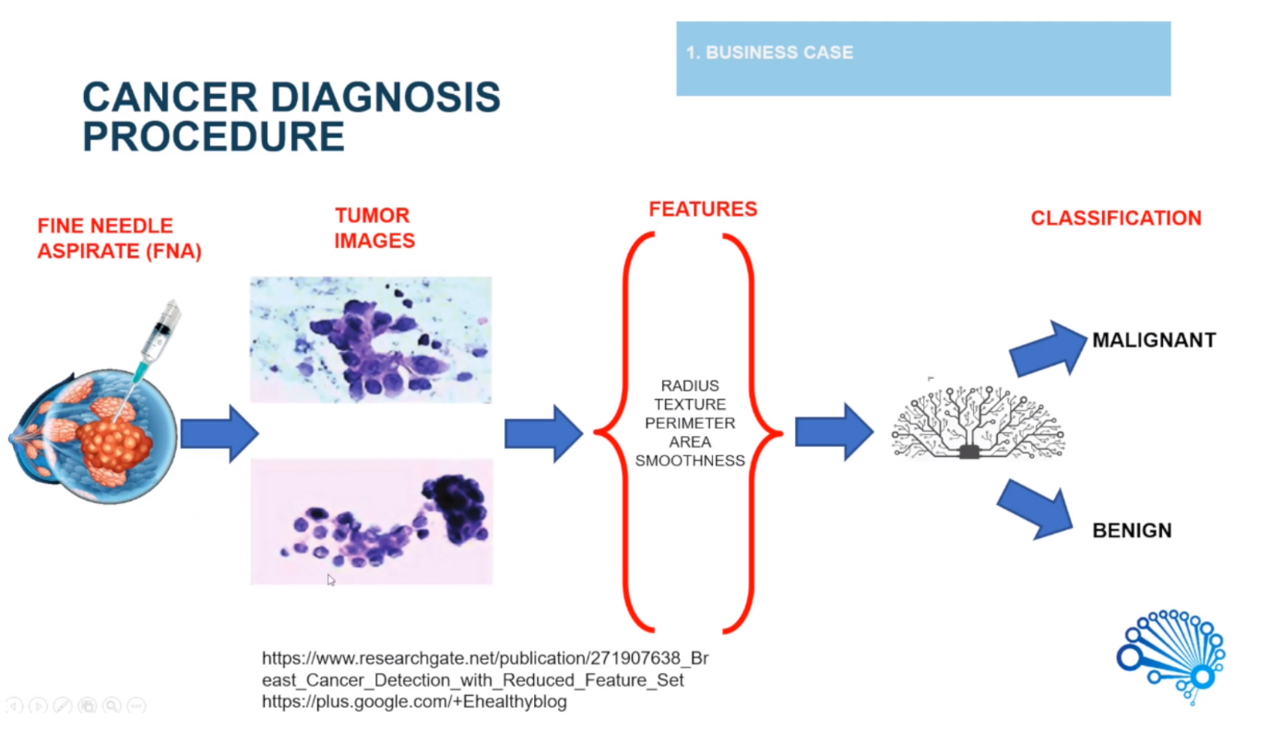Malignant – Cancer, Benign – Non-Cancer Lumps.

Extract the Feature out of the Features, eg. Radius, texture, perimeter, area and smoothness

Put the Features into the Machine Learning Algorithm to Classify Images.

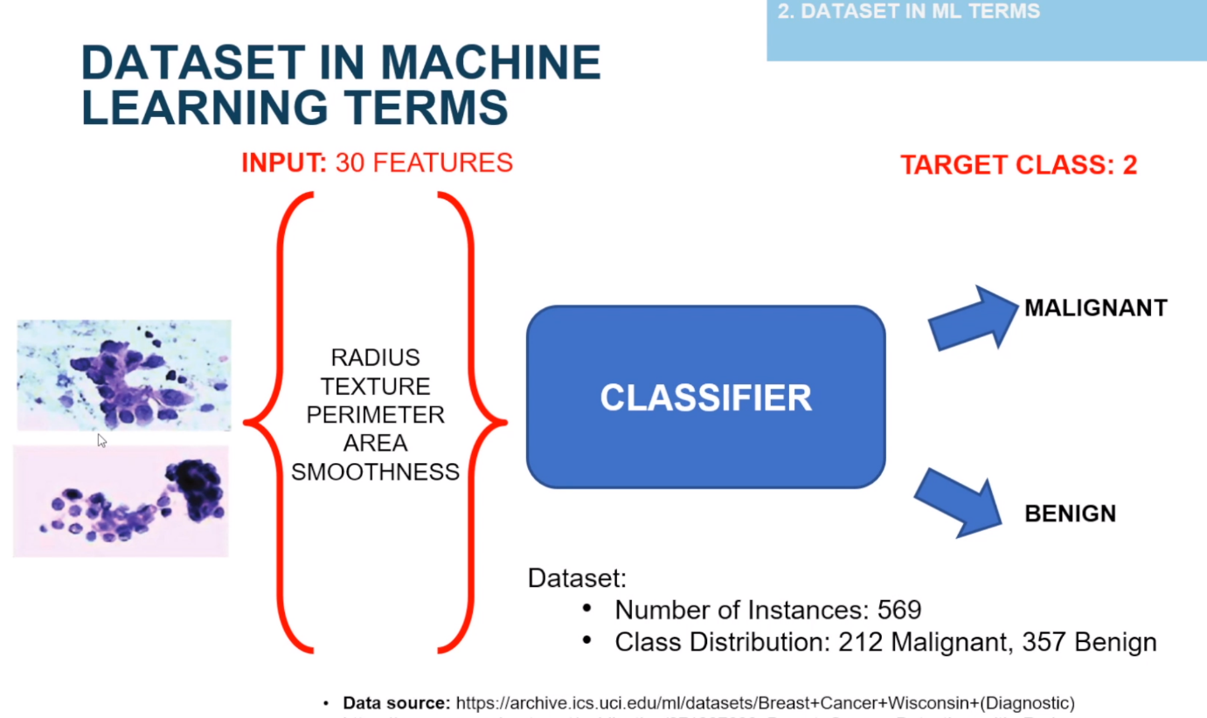The Dataset is already provided. Feed them into the Classifier. 569 Instances. Binary Output Maligant or Benign.

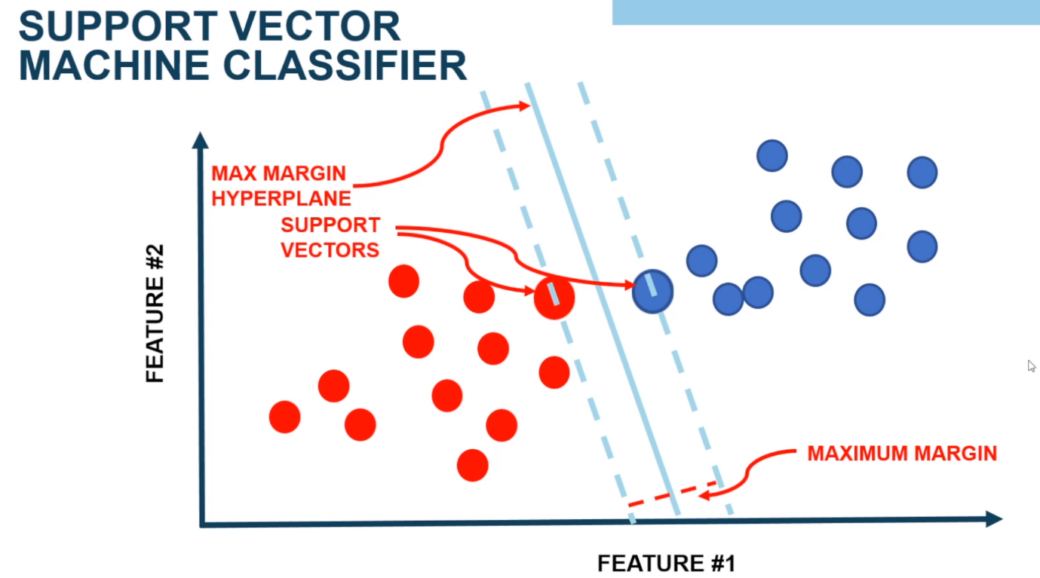ML Recommended to use : Support Vector Machine Classifier.

Hyper Planes . SVM uses the points that are on the boundary and then separate them into classes.

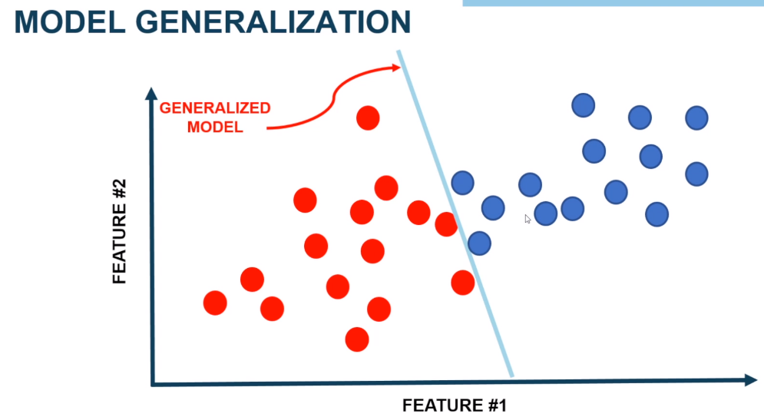Model Evaluation – Ensure that our models are general

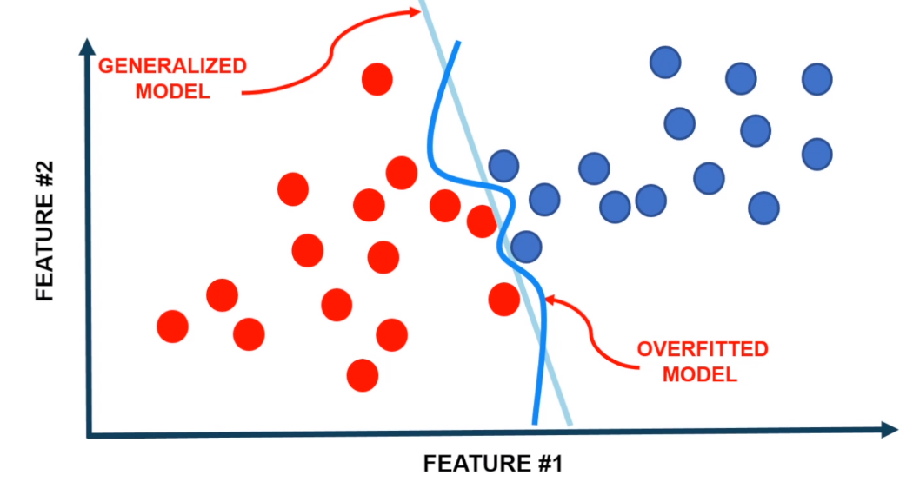We can draw a boundary specifically fit our dataset – Overfitted model.

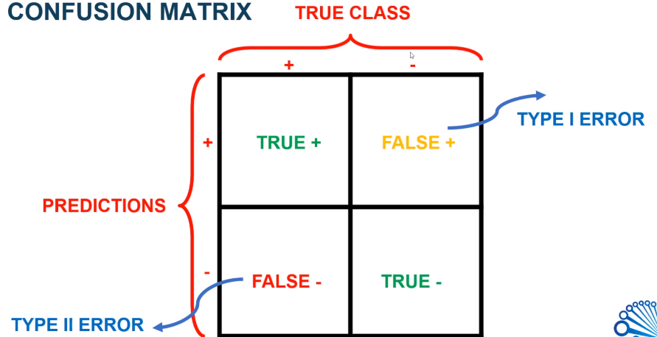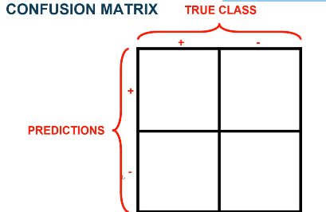Evaluation – Confusion Matrix

Type 1 Error – Patient is Fine but True Class suggest that patient has cancer

Type 2 error – Patient is not fine but True Class suggest that Patient is Fine

Improve the Model

1. 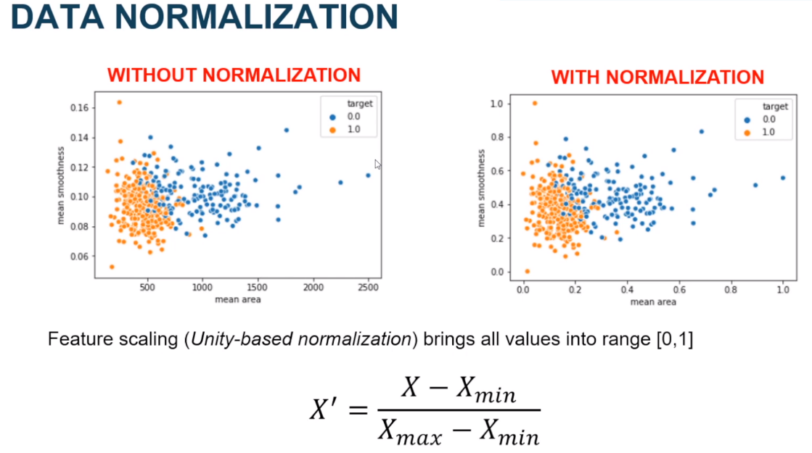Data Normalization - Unity based Normalization or Feature Scaling
2. SVM Parameters Optimization (Grid Search)
   1. 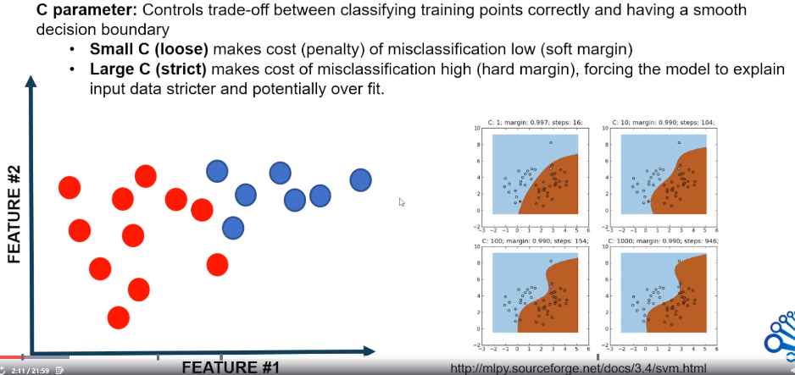C Parameters: Specify the Penalty, Small C means Loose Penalty. High C, means strict. Need to be wary of Overfitting
   2. 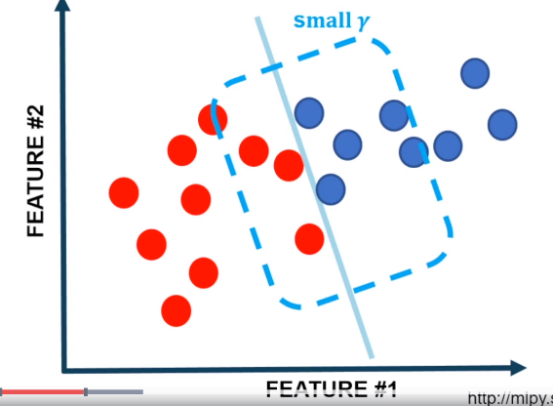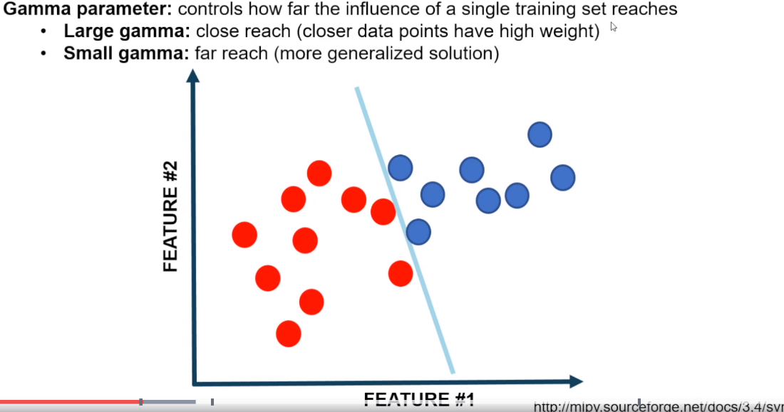Gamma Parameter – Large Gamma means close reach, Overfitted. Small Gammer

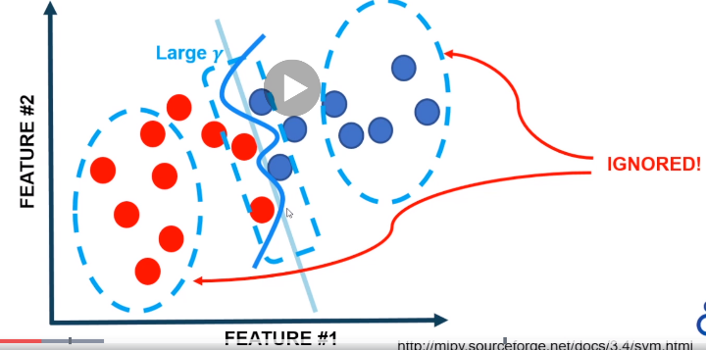

CONCLUSION

